

Year 7

Investigation 2

Number and Algebra

Total Marks: marks
Name: ______________________

Section One- In-class

Baldivis Secondary College is looking at the option for arranging the tables and chairs in the different classrooms.
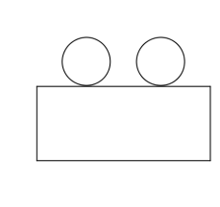
One option is to have rectangular tables. With each table having 2 chairs.

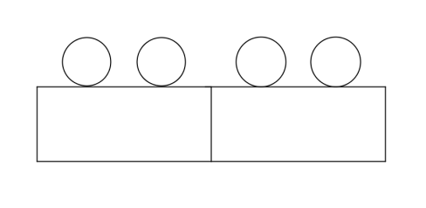
With 2 tables you need 4 chairs as in the diagram below

With 3 tables you need 6 chairs as in the diagram below
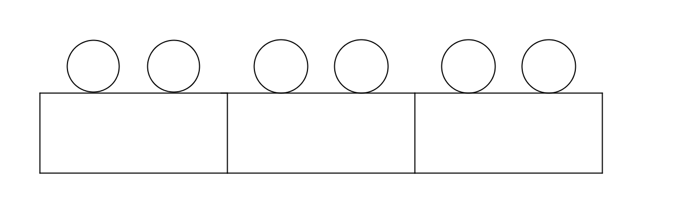

- Draw the diagram for:

4 tables

5 tables

- Fill in the table showing the number of chairs and tables.

Number of tables (T) | Number of chairs (C)
1 | 2
2
3
4
5
6

- Describe any pattern that you can see in the table.

- How many chairs are required for 6 tables?

- How many chairs are required for 7 tables?

- Another way to find the number of chairs is to find a rule between the number of tables and the number of chairs.
Complete the following sentence describing the rule for finding the number of chairs.

To find the number of chairs you ………………..

- Instead of using words to write the rule, we can use letters and symbols. Let C be the number of chairs and T be the number of tables. Write a rule using symbols and letters

- Using your rule, how many chairs would you need for 12 tables? Justify your answer.

- If I needed32 chairs, how many tables would I need?

Year 7

Investigation 2

Number and Algebra

Total Marks: 24 marks
Weighting 30%
Name: ______________________

Section Two – Take Home Section
Question 1
(12 marks)
Baldivis Secondary College is looking at the option for arranging the tables and chairs in the different classrooms.
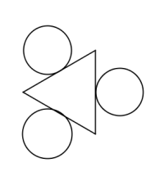
One option is to have triangular tables. With each table having 3 chairs.

With 2 tables


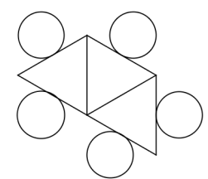
With 3 tables

- Draw the diagram for:

4 tables

5 tables

- Fill in the table showing the number of chairs and tables.

Number of tables (T) | Number of chairs (C)
1 | 3
2
3
4
5

- Describe any pattern that you can see in the table.

- How many chairs are required for 6 tables?

- How many chairs are required for 7 tables?

- Write a sentence describing the relationship between the number of tables and the number of chairs.

- Let C be the number of chairs and T be the number of tables. Write a rule using symbols and letters between the number of tables and the number of chairs.

- Using your rule, how many chairs would you need for 10 tables? Justify your answer.

- If I needed30 chairs, how many tables would I need?

Question 2
(12 marks)
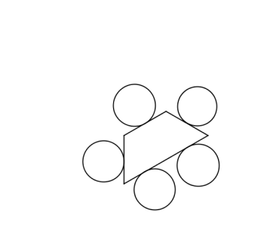
Another option is to arrange the tables and chairs differently. As shown in the diagrams below
With 1 table

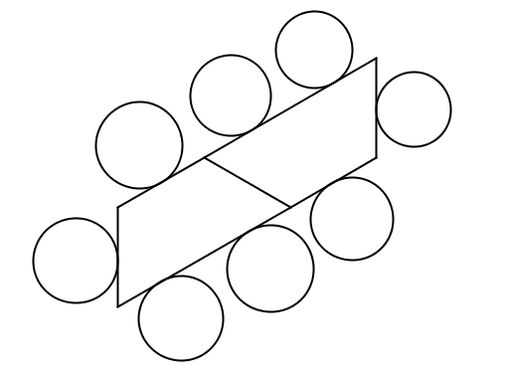
With 2 tables

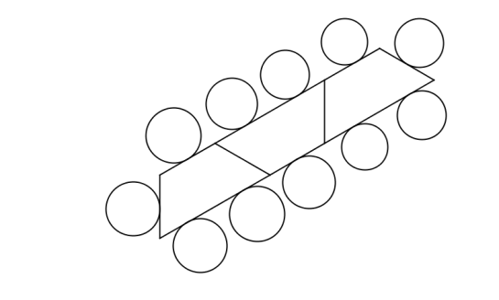
With 3 tables

- Draw the diagram for:

4 tables

5 tables

- Fill in the table showing the number of chairs and tables.

Number of tables (T) | Number of chairs (C)
1
2
3
4
5

- Describe any pattern that you can see in the table.

- How many chairs are required for 6 tables?

- How many chairs are required for 7 tables?

- Complete the following sentence describing the relationship between the number of tables and the number of chairs.

The number of chairs is equal to _____ times the number of tables plus _____.

- Let C be the number of chairs and T be the number of tables. Write a rule using symbols and letters between the number of tables and the number of chairs.

- Using your rule, how many chairs would you need for 12 tables? Justify your answer.

- If I needed32 chairs, how many tables would I need?

Year 7

Investigation 2

Number and Algebra
Total Marks: 30 marks
Weighting 70%
Section Three- In- Class validation
Question 1
(12 marks)
Baldivis Secondary College is looking at the option for arranging the tables and chairs in the different classrooms.
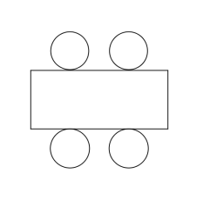
One option is to have rectangular tables. With each table having 4 chairs.

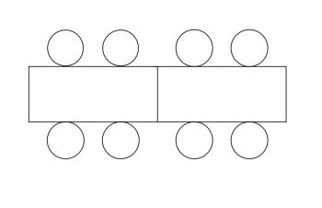
With 2 tables you need 8 chairs as in the diagram below

With 3 tables you need 12 chairs as in the diagram below
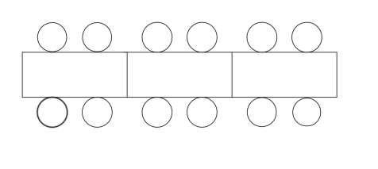

- Draw the diagram for:

4 tables

5 tables

- Fill in the table showing the number of chairs and tables.

Number of tables (T) | Number of chairs (C)
1 | 4
2
3
4
5

- Describe any pattern that you can see in the table.

- How many chairs are required for 6 tables?

- How many chairs are required for 7 tables?

- Write a sentence describing the relationship between the number of tables and the number of chairs.

- Let C be the number of chairs and T be the number of tables. Write a rule using symbols and letters between the number of tables and the number of chairs.

- Using your rule, how many chairs would you need for 12 tables? Justify your answer.

- If I needed32 chairs, how many tables would I need?

Question 2
(18 marks)
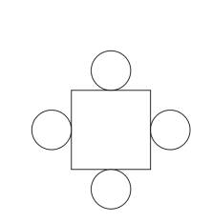
Another option is to arrange the chairs differently. As shown in the diagrams below
With 1 table

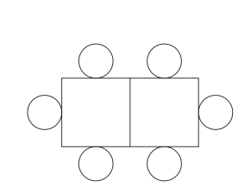
With 2 tables

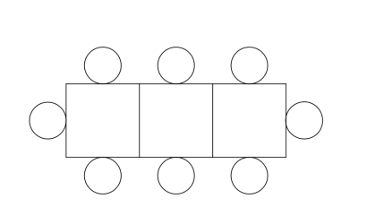
With 3 tables

- Draw the diagram for:

4 tables

5 tables

- Fill in the table showing the number of chairs and tables.

Number of tables (T) | Number of chairs (C)
1 | 4
2
3
4
5

- Describe any pattern that you can see in the table.

- How many chairs are required for 6 tables?

- How many chairs are required for 7 tables?

- Complete the following sentence describing the relationship between the number of tables and the number of chairs.

- Let C be the number of chairs and T be the number of tables. Write a rule using symbols and letters between the number of tables and the number of chairs.

- Using your rule, how many chairs would you need for 12 tables? Justify your answer.

- If I needed32 chairs, how many tables would I need?

- Someone suggests that one way of working out the number of chairs is to add one to the number of tables and then double the answer.
- Write this using symbols and letters

- Find the number of chairs required for 12 tables.

- Is this rule for finding the number of chairs equivalent to the rule you found in part (g).

